**Programming the MSP430**

To program the MSP430, you have to use the programming connector J16. You also need to use the MSP430 development board (Launchpad) for the programmer and the custom cable that has jumpers to connect the programmer to the custom PCB.

You probably remember this from Embedded Systems, but to open the file inside of Code Composer Studio, you should go to File -> Import -> Code Composer Studio -> CCS Projects and then navigate to and select the project.

1 - You need to remove the jumpers from programmer side of the development board to the processing side of the development board.

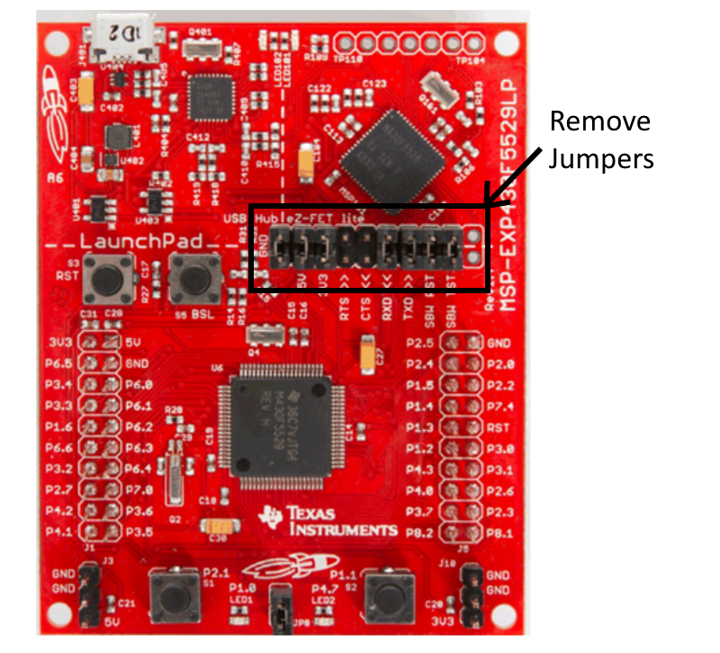

2 – Use the custom cable to connect the SBWTCK_HOST, RST_SBWTDIO_HOST, and GND pins from the **programmer side of the development board** header to the custom PCB. (See “Isolation Jumper Block” portion of the image below)

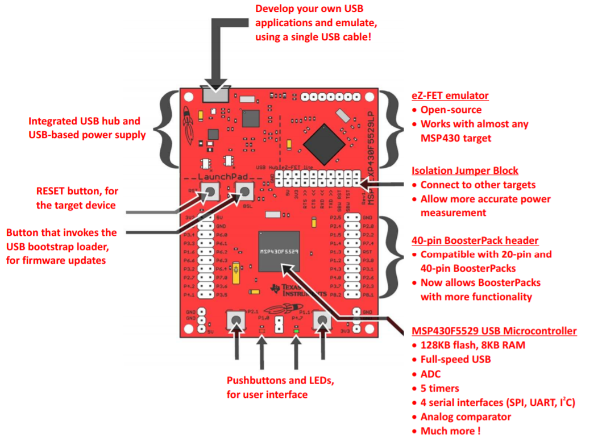

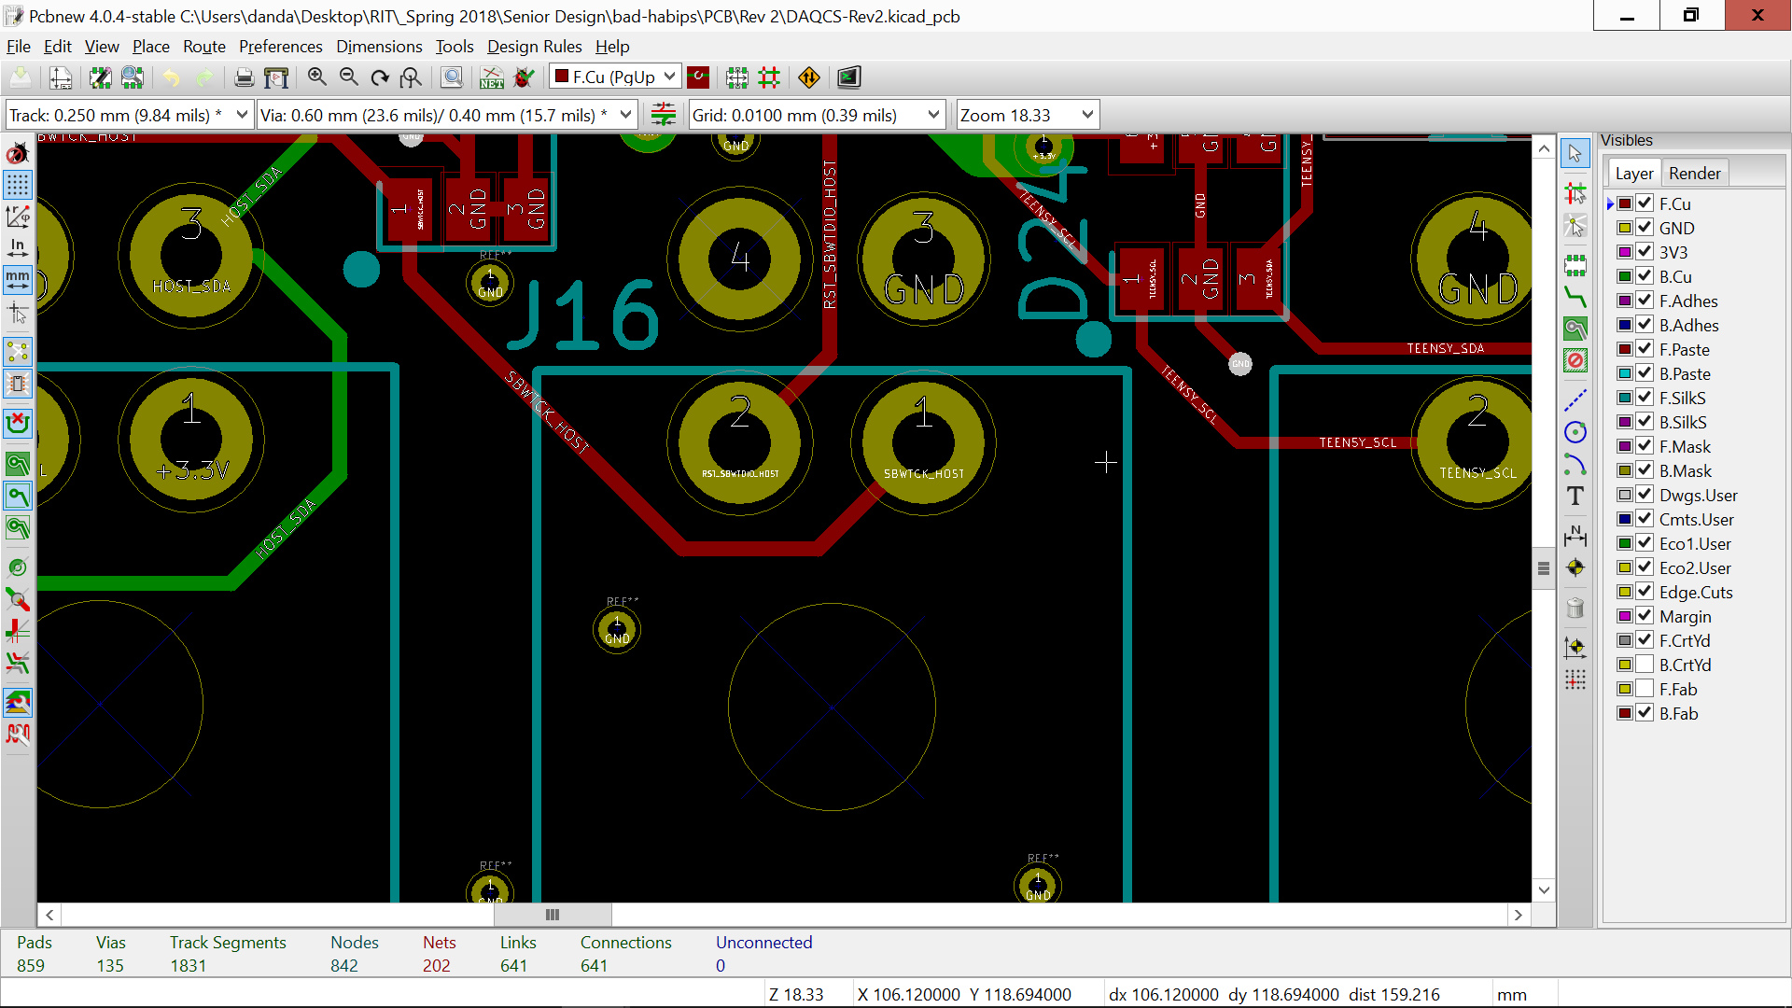

3 – Power on the DAQCS board so the MSP430 has power

4 – Connect the programming PC running Code Composer Studio to the development board programmer via USB to micro USB cable.

5 – Upload and run your program